Brandon Borowiak

Existential America

13 December 2019

**Despair Lies Within All**

*The more something threatens your identity, the more you will avoid it.*

--Mark Manson, The subtle Art of Not Giving a F*ck

**1. Prologue**

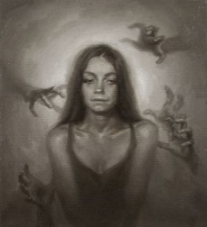I have now learned how a girl could go from running in track, representing her high-school in a statewide program for female leaders, and taking eight placement exams (one of which she taught herself the material) to plummeting into the ferocious grip of depression and suicidal thoughts. I have picked at the mind of a man who stalked his wife for twenty years. I have now seen a girl sunk into a chair expecting her boyfriend to walk through the door one more time, even after she was just at a party where she was hitting on everyone (boy or girl) and even kissed one of them. I have seen a man, who was afraid of how to look at a group of uniformed Catholic children fearing what they would think of him and was mind-blowingly socially awkward to his coworkers and judged another man for having his bangs cut in a straight line and judged the same man for wearing gym shorts and was obnoxiously anxious when this same man did not acknowledge him after walking past him, fling off his loafers and jump into a rushing river to save two girls that he had never seen before. I have now awkwardly sucked on the top of an empty water bottle and stared at my phone to make it look like I was not eavesdropping on a man trying to convince a woman that having an abortion is no big deal. I have been told to choose what I pay attention to[1]. I have now occupied an elevator with a man that snapped (furiously) at a woman for looking at his feet (even though she probably was not); this man would then blow his brains out with a handgun on a twin bed with a girl lying, paralyzed in sleep, on the twin bed next to his shortly after returning to his room.

**2. Confession**

 I have now lied to every single reader of this essay. Perhaps “lied” is not the correct term to use here; “stretched the truth” is probably a more accurate description of what I have inflicted upon all of you. Every statement I made within the prologue are not things that I have experienced physically, but they are all from literature. The texts that I pulled these statements from were all read during a class I am taking during the fall semester at the University of St. Thomas (MN). This class is called “Existential America,” focusing on the philosophical concept of existentialism[2]. This concept forces one to think critically about the decisions they make and to view themselves from an outside perspective. Looking back on myself, I am a jigsaw puzzle of different experiences. This puzzle also consists of the works of literature that I have read during this class. Although they were not physical experiences, they still have an impact on who I am and my perspective on the world. This, in turn, creates another piece of the puzzle.

When I left my hometown of St. Michael, Minnesota, to come to this brilliant university, I told myself that I was leaving one life to begin another, and that I could totally change who I am as a person, but this could not be further from the truth. I can create more pieces of the puzzle, but I can’t remove them. One section of this hodgepodge of a puzzle are the accomplishments I have achieved during my life; including my almost 3.9 grade-point average and my solid ACT score[3]. These accomplishments created the opportunity to come to a college as great as St. Thomas. However, these were not the most impactful aspects of my life that changed the path that I was on. Instead, failure is what led to me sitting in this class at 12:15 PM, every: Monday, Wednesday, and Friday. I still dwell on my failure to reach my life-long goal of playing college soccer[4], and this still takes a toll on me mentally. Finally, after six (long) months of hoping, I let my dream fall from my desperate hands. Therefore, making St. Thomas the best option for my academics because of the record that it holds.

**3. Contingency**

As an introvert[5], I have spent much of my life sitting at home watching hours of YouTube videos or Netflix shows; this was comfortable. This was sort of the environment that I grew up in. It was not my choice to grow up in a household full of very individualistic people, or to grow up in a very homogeneous society. Most importantly, I did not get to pick my parents; who are the most influential people in my life (as they are for many people). I can thank the lucky roll of the dice that allowed one of the most influential figures in my life, my dad, to raise me. Although I grew up extremely introverted, I have recently found myself exploring vast jungles of new activities. To me, it seems as if I am no longer comfortable with the comfortable. I feel as if I am missing out on a more exciting life by retreating to my relaxing futon or queen-sized bed every single day. This recent feeling inside of me is a result of some advice that my father gave me during January of my freshman year of college. After I told him of some of the enthralling stories of my first semester he responded with: “You don’t make memories being cautious.”[6] I have not let this idea go since that January day, and I have found myself desperate for new experiences ever since. I did not get to choose my parents or the place I grew up, but these are the most influential parts of my life. Even after I have ventured into a new life at college, I still find them impacting my life more than ever before.

 Jon Krakauer showcased the life of Chris McCandless’s life in his story: *Into The* Wild. Although every place Chris threw himself, there was randomness, other characters within the story also had contingency affect their lives. Ronald Franz was an 80-year-old, and a past drunk, and a war veteran, and a man whose wife and kid were slaughtered at the hands of a drunk driver on New Year’s Eve, and a man who picked up Chris McCandless off the side of the road while McCandless was living a nomadic lifestyle. The death of his wife and child was a very contingent event on its own, and it had a drastic impact on Franz. He would, afterwards, cling to alcohol to cope with the despair that is encapsulating him. Although this event, obviously, rattled the heart of the war veteran, this even does not seem to be the most petrifying random event that occurred during his life. It was the death of McCandless that tore this man from his own identity. Franz’s downfall by Chris’s death is, without doubt, because of how Chris changed his life. In a letter, McCandless wrote, “…begin to boldly do things which you may previously never have thought of doing, or been too hesitant to attempt[7]” (56). This piece of advice led the 80-year-old to go and live in the desert; at the same camp McCandless had stayed while in town. This shows how deeply McCandless had carved himself into Franz’s life. This fact was then exemplified when McCandless was found dead in an abandoned bus in Alaska, because Franz fell into one of the deepest pits imaginable. After hearing the news, he withdrew himself from his church, which he had remained a part of after the ruthless taking of his wife and child. However, just like when his wife and kid died, he also turned to alcohol; he took a bottle and drank it at the campsite where McCandless had stayed. This reaction shows the how incredibly impactful picking up some person off the side of the road had on his life.

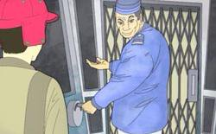 Holden Caulfield, in the novel: *The Catcher in the Rye*, lived a life surrounded by contingency. Seemingly daily, there would be another experience[8] that would shape him as a person. Whether it was meeting the mom of a student at the school he had just been kicked out of or talking to two nuns at a bar, he could not get away from these strange encounters. Another one occurred on a hotel’s elevator, just a couple days after he had been kicked out of school. Maurice was a pimp who would meet Caulfield on the elevator, who would then ask if he was interested in a girl coming over that night. Caulfield agreed, seemingly fine to know that he would be losing his virginity to a hooker. However, once the hooker (named Sunny) arrived, Caulfield was not interested in performing any sexual acts with her. He said, “I know you’re supposed to feel pretty sexy when somebody gets up and pulls their dress over their head, but I didn’t” (106). He would later tell her: “I’ll pay you and all, but do you mind very much if we don’t do it?” (107). I believe these two quotes truly reveal the level of loneliness that he contains within himself. Even though he paid for this hooker to come over and have sex with, all he wanted was someone to talk to. After refusing to follow any of the advancements made by Sunny, Caulfield paid her the five dollars; this was contested because she said that her fee was ten dollars, but she took the money and left. Maurice would then return with her at the middle of the night to demand the rest of the fee. The pimp would physically assault Caulfield until they took the money out of his wallet and the left as Caulfield was lying on the floor, crying. This interaction would not have happened if he did not end up on the same elevator with Maurice, but it left him on the floor crying, missing ten dollars, and still having the internal struggle of loneliness.

 Contingency affects every single person that is walking on this strange ball of rock[9] orbiting a sphere of fire from hell. It seems that the most impactful moments of everyone’s lives are based off the random events that they have experienced. For instance, we did not have the opportunity to choose our parents before we were born, and these two people are (more than likely) the most influential figures in everyone’s lives. Sadly, randomness leaves a sour taste in many people’s mouths because humans, by nature, like being in control of their surroundings. 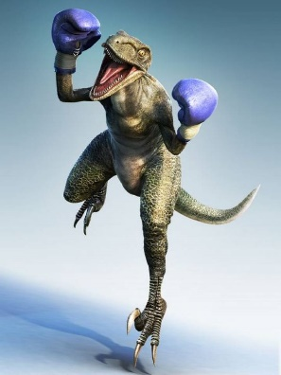Exams are a good example of this because each person has no idea if the exam, they are about to take, is going to be like petting a lovable, soft, orange kitten, or if it is going to be boxing a dinosaur the size of the Empire State Building. There’s that common phrase, “If you stress about something too much before it happens, then you basically put yourself through it twice.” Which is why I ask, why must we be so anxious about something that we can’t control? There are so many positives that come out of randomness as well! How did we all meet our best friends, or our significant other; how did we figure out our favorite activities? In some way, contingency has played a role in every single good experience we have in our lives. Therefore, I believe randomness should be welcomed instead of feared.

**4. Alienation**

I grew up with hardly any alcohol in my life. Mainly because my dad gave up alcohol[10] when I was about seven years old, and then my mom only had a glass of wine on occasion. Since I grew up with, basically, the complete absence of alcohol, I continue to live my life that way. To this day, I have never even taken a sip of alcohol and I will be twenty in almost a month. This is practically unheard of (at least from all the people I talked to) for this period in everyone’s lives. In the context of college, I can’t help but feel like I’m ostracized because alcohol is prevalent almost everywhere within this society. Even though I feel as if I have been cast out, I still stand by my belief that you do not need alcohol to have a good time[11]. Luckily, I have a friend group that is very understanding of my belief on the use of alcohol, so I feel like I have a safe-haven that allows me to feel welcome. However, this does not completely exclude me from the peer-pressure from them. There are also many acts that they do that tell me they would prefer that I did drink; for instance, they will constantly ask me: “when will you start drinking?” Although there is an immense pressure from fall around, it has not affected my stance against alcohol. It’s important for me to recognize that one needs to hold their values close to oneself so that one does not simply conform to the one’s around you.

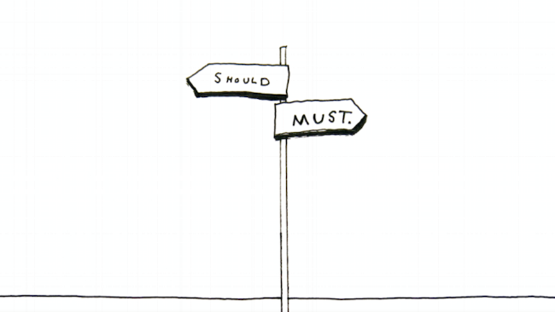 In Neil Labute’s play: *The Shape Of Things*, Adam, over the course of the play, would be completely alienated. Although alienation is commonly thought of as being cast out from society, Adam becomes cast out from his own self. The force that perpetuated this separation was a woman by the name of Evelyn. Over the course of the romantic relationship between these two, Evelyn managed to change many different physical aspects of his. Including: his weight by having him work out, his hair style, wearing contacts instead of glasses, eating a better diet, and Adam getting a tattoo[12] of Evelyn’s initials. What’s incredibly interesting about all these changes, was that Evelyn never forced any of these upon Adam. She would simply suggest that he should change these things, and he would. The most significant change would be him getting a nose job, although he had some difficulty making this decision, Evelyn managed to use language that would make him more comfortable with the idea. The reader does not learn anything about the state of mind that Adam was in before Evelyn, so we don’t necessarily know if he was uncomfortable with who he was beforehand. However, in a short time Adam looked completely different; Evelyn stated in her presentation: “It does mark the beginning of my systematic makeover, or ‘sculpting,’ if you will, of my two very pliable materials of choice: the human flesh and the human will” (76).[13] Here, she is talking about how she managed to play with his mind and body and change him into a completely different human being. She managed to change him physically, but these changes also led to mental changes. This included in him being comfortable with having sex in a public bathroom and cheating on Evelyn with his best friend’s fiancé. These changes completely alienated him from his true self. He was not necessarily comfortable will all these changes (the nose job in particular), but with subtle coaxing he was able to be sculpted into a new human. Now, he will probably view himself as just a product of someone else’s creation, and he will 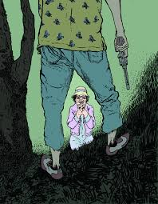never, completely, be able to return to the person he once was.

The Misfit, in Flannery O’Connor’s short story: *A Good Man Is Hard to Find*, was a man that entirely cast out from society. Which is very different from the alienation that Adam had experienced. The Misfit performed horrendous acts in multiple different instances, and these only separated himself further from the societal norms. How many people view this misfit was shown through the grandmother when she said, “Here this fellow that calls himself The Misfit is aloose from the Federal Pen and headed toward Florida… I wouldn’t take my children in any direction with a criminal like that aloose in it” (137). It’s interesting trying to understand how someone could go so awry in society. In the short story, the reader is given some hints towards why the Misfit may be set apart from everyone else. The Misfit says, “God never made a finer woman than my mother and my daddy’s heart was pure gold” (147). He would later say, “My daddy said I was a different breed of dog from my brothers and sisters” (148). This shows that he must’ve grown up in a good family, but, from an early age, he was already cast out from everyone else. From what the reader knows, it seems to mainly be at the hand of his father. What’s very interesting, even though he understands what he is doing is wrong, he remains unchanged from these terrifying acts. Which only furthers him from the societal values that holds him apart from the majority.

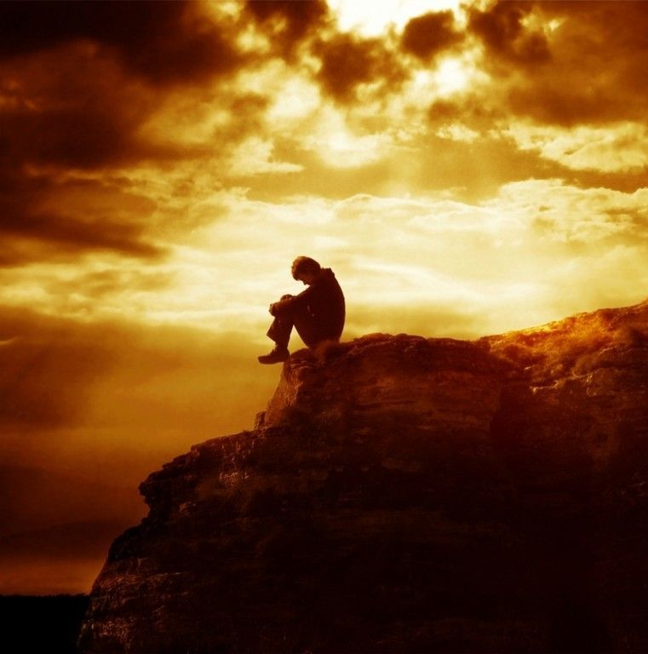 When thinking about alienation, I think it is important to realize that alienation is a result of one’s own doing. For example, if one felt they were being cast out, they could change who they are to fit in. Like Adam in *The Shape of Things*, he tried to conform himself to Evelyn’s wants so that she would accept him, and the Misfit could become a law-abiding citizen to be welcome, but he does not. I want to provide the argument that alienation does not always have to be in a negative light.[14] Like in my instance, I may not be welcome in certain groups of people because of my lack of alcohol, but this means that I can find the true friends that will respect me for who I am. Since there are positive effects of alienation, I believe that people should discover when they should be comfortable with being set apart, and when they should not be. In my situation, I would argue that I should not change because I am happy with where I have placed my beliefs and these beliefs are not causing harm towards others. If I did change where my values lie, I would just be another sculpture created by the people around me.

**5. Authenticity**

 I am someone who has many different masks to wear during different situations. Does this make me unauthentic? Many non-existentialists would argue “yes.” However, to the existentialist they would believe that I am entirely; this comes from the definition: “Being who you need to be for the situation.” Which is a contradicting belief than what many stereotypical high schoolers would believe. The saying: “two-faced bitch,” is probably a phrase that has come out of many of these teenagers’ mouths. This classification is laughable to the existentialist; because every single person does not act the same in every situation. For instance, one would not act the same in a job interview as they would at a party on Friday night. The movie: Before I fall, illuminates this idea perfectly. There is one scene on Cupid Day[15], where a group of four girls (including the main character: Samantha) were sitting at the lunch table and judging a girl for the way she looks. They were all classifying her as a “bitch.” After falling into a loop of living the same day over and over, Samantha tries to, not necessarily befriend, but to gain the trust of the “bitch.” In this case, Samantha was displaying a much more compassionate side of herself. The existentialists would argue that in this case, she is being incredibly authentic because she’s acting completely different with very different people.

After learning the existential belief of authenticity, I have only uncovered all the different masks that I wear daily. There’s the quiet, reserved mask that I will wear to every single class 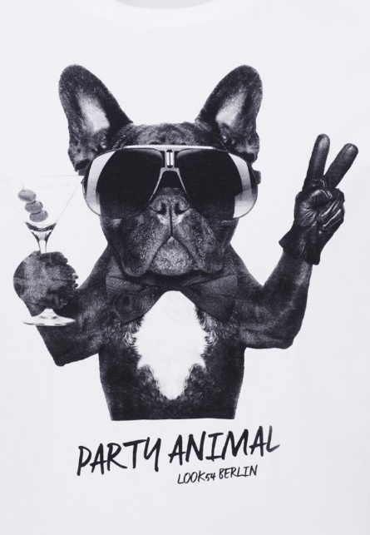period[16]. There’s the energetic, party animal mask that is visible almost every single weekend. This mask is when I truly feel at my most authentic and happy because it comes so naturally to me; I feel like this is not a mask that I must force on. There’s the social, but relaxed, mask that I put on during the horrendous family gatherings every holiday; which drive me through the roof because I cannot stand small talk. There’s the hard-working, energetic, goofy mask that is strapped around my face while I’m at work, even if I’m in a swirling tornado of homework. There are also thousands more that sit in my back pocket for any situation that is thrown my way. I believe that having, what seems like, infinite possibilities allows me to have relationships with a variety of people. Which, for me, is much more valuable than any amount of money possible[17].

Morse, created in the story: “The Falls,” written by George Saunders, seemed like a very one-sided man: a broken man. He wore this negative, and stressful face almost the entire story. Everything that he encountered on his walk home was viewed in a depressing light. He disliked the owners of expensive mansions, just because of the wealth they had. Another character, Cummings (that Morse thinks is kind of a loser) does not pay attention to Morse as he walks by, and this leads to Morse getting stressed out because he is worried that he upset Cummings in some way. All these reactions create this idea that Morse is just a helpless man. This is the mask seen entirely until the very ending of the story. He showed his authentic self when he saw the two girls on a canoe floating towards the Falls. With slight hesitation, he showed his authentic self. Saunders wrote, “…he was needed at home, it was a no-brainer, no one could possibly blame him for this one… he kicked off his loafers and threw his long ugly body out across the water” (188). Although he knew the risk that he could fail and fall to his death with them, he decided to attempt to save them. It is very interesting because he resented the rich home owners even though he had never met them; but, he sees these two girls on the verge of death, and he can’t help but feel obligated to help them. This shows the drastically different sides to Morse, which means, to the existentialist, that he is showing his authenticity.

Dolores, from Ben Greenman’s story: “What 100 People, Real and Fake, Believe About Dolores[18],” has many different faces that she used during different situations, and these were all shown through 100 different perspectives on her life. The reader learns of a time where she would rather be lazy instead of helping the people who are kind enough to be helping her. This is shown when a friend of her boyfriend said, “That she wasn’t so helpful… a bunch of friends went over to give them a hand. That she said she was supervising” (199). Clearly taking advantage of the kind individuals so that she can kick back and relax. In contrary, we learn of a time where she seems to be hard working. This appears when putting in effort will help her achieve her dream of becoming a famous musician. The reader learns of this when her old music teacher talked about how incredible she was. A third face was discovered when she was in a party setting. A sort of party animal face (one very different than mine) where she would continually pour another drink and would then walk around and flirt with anyone at the party. These three faces show the authenticity, according to the existentialist, of Dolores. That she would take on different persona’s in different situations; very interestingly, it seemed as if she had put on these different masks for only the benefit of herself. Although, it is kind of unsettling to think of someone acting differently for only their own benefit, to the existentialist, this is authenticity.

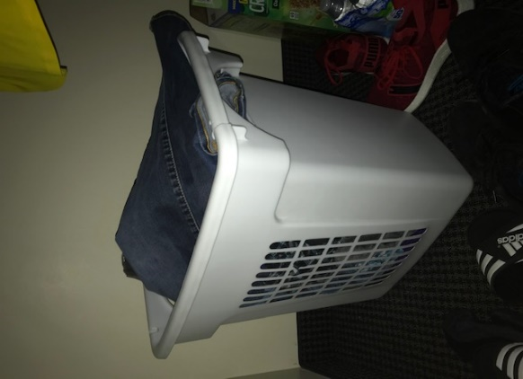 I believe that it is ignorant to believe that authenticity is the idea that one person should act in one way in every situation. Therefore, I think that it is important for everyone to understand that they have a choice of how they are going to act in any given situation. This leads into Tolstoy’s three questions. The first one being: “Who is the most important person?” Which Tolstoy believed the correct answer was the people around you. Tolstoy’s answer tells us that authenticity matters; because whatever mask you are wearing in the current situation, changes how the people nearby perceive you. The difficulty appears when one is choosing what mask to wear. Whether for a job interview or a party on Friday night, one must figure out which mask is the best for the given situation.

**6. Identity**

My mom’s obsession with cleanliness[19] introduced a large, white, standing, plastic, laundry basket into my room (which I believe was when I was about eleven years old). Along with this, came the words, “You have to start putting your clothes into this instead of the floor.” After I threw a fit because I’m one stubborn human-being, I complied to her demands. Since this day, this laundry basket has stood tall inside my bedroom’s closet, or within my dorm room since I went off to college. This basket has undergone multiple instances of abuse, which was mainly due to my playfulness as a child. This has left the laundry basket with scars and dents imbedded within it. Yes, I liked to sit inside of it and play with Sammy and Sophie through the holes on the side when they were still around. Yes, I should not have tried to ride down twelve stairs inside of it; which created a crack next to the handle that is still annoying to this day when I’m carrying it to the laundry room. Yes, I should 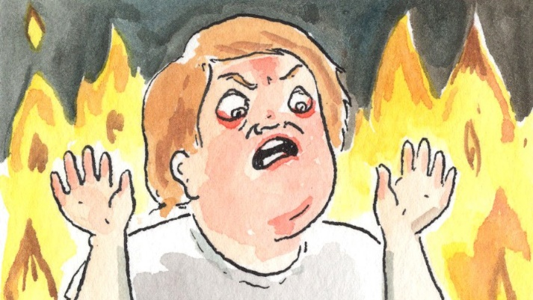not have thrown it down those same stairs on multiple occasions just to answer the ridiculous question of: how loud of a noise will this make? It also suffered the incinerating rage (which involved me kicking it across the room) of when I got zero percent on a homework assignment[20] in the spring semester of my freshman year in college. This basket also holds other characteristics of myself inside of it. Including, my incredible laziness. As I write this section, it sits within my room full of clean laundry from two days ago. Instead of folding this laundry, I have just been picking out my favorite items as needed; and beside it, a pile of horrifically smelling, dirty laundry has accrued. This basket also holds some of the greatest memories of my life within it; including, my old soccer uniforms after those incredibly muddy games, and the drenched, winter clothes that were brought in after building snow forts in the pile of snow left in the cul-de-sac down the street[21]. This laundry basket also holds the worst of times, like the bloody clothes after I walked home, crying, because the asshole kid down the street hit me with a metal shovel when I tried to destroy his snow fort during a snowball fight, or the Aéropostale shirt[22] that was forever stained after my mouth surgery[23]. Nothing has stuck by my side closer than this basket, which until now, never got recognition for the pain that it has endured.

1. Damn, this is something my mom needs to hear. She continually comes home from work pissed off at how bad traffic was, or how busy the store was. If only she could have the same experience I had. Maybe she would not be so pissed off after almost every single day at work. For me, this piece of advice allowed me to realize how out-of-control my thoughts are when I work also. As someone who prides myself on how hard I make myself work at my trashy cafeteria job, I get pissed off whenever someone else is not pulling their weight. For the most part, I do not let these feelings ruin my whole day, but they definitely affect it. Maybe if I consider that they are probably having a much worse day than I am, for instance: a family pet died or they have three tests the next day, then I may, possibly, get motivated to work extra hard to cover for them.
2. I had no knowledge of this concept coming into the class, but this class has helped me understand that I am obsessed with different ways that people view the world.
3. My ACT score is viewed by many as very good, but to this day I am still ashamed of it because it does not meet the standards that I have set for myself. So, I do not like sharing it.
4. My entire life was shaped by me playing soccer, and I was hoping my future would be too. With multiple offers from different colleges around the mid-west to play soccer, this university was not even on my radar. However, with one wrong step; my body collapsed to the artificial grass field (over the excruciating pain of my ruptured knee). Falling shortly afterwards was my mental health, but also the shattering of the biggest dream I had.
5. I commonly prefer to spend my weekends sitting on my very squeaky, but somehow very comfortable futon in my apartment; while I watch professional soccer or whatever show I am binge watching on TV. All this instead of going out with friends.
6. It’s interesting reflecting on how much I have changed as a person after this piece of advice, and it has led to some of the greatest memories I have ever had. Including one day where I was convinced to go to the Gay 90’s (a LGBT nightclub). Which was never a possibility until I had this life changing event.
7. I feel like this advice is very similar to the one my dad gave me. To not keep living in the comfortable. However, I don’t think living in the desert is the sort of experience I’m looking for.
8. I believe that everyone experiences some random event every single day, but not much attention is paid to it. For example, the weather is completely random every single day. Research has shown that the weather has a drastic impact on our mood throughout the day; this is displayed by the fact that alcohol is banned in different places in Alaska because many people would fall on alcohol when there would be days with no sun. We hardly ever acknowledge the weather as random, but we simply have no control over it. On top of that, it plays a massive role in our daily activities.
9. Since I do not have any religious affiliation, the fact that we are living on this giant ball of matter is probably the most contingent fact in life. That humans somehow ended up surviving on this planet when there are billions of other possibilities.
10. I think it is very admirable that he did this. He told me that he used to have a beer or two every single day, but he started to feel like it was unnecessary. This is what motivated him to quit, and this is what has motivated me to stay away. I think it is incredibly admirable that he was searching for a way to better himself.
11. In a party setting, people are blown away with how I act without the influence of alcohol. Let’s say that not many other people will dance on the kitchen counter and take their shirt off. Many people will often say that I act more drunk than the actual drunk people at the party.
12. I don’t’ understand the purpose of tattoos. The mind decides what has meaning in one’s life, and the mind will work to keep track of what has the most meaning in life; so, why must one print this on one’s body?
13. This is truly a disturbing thought. What if every person that we interact with is just trying to sculpt us into one of their own creation? Obviously, this is almost positively not true, but it’s a terrifying thought. I want to thank Professor Phillips for having me read this play because now I’m going to second guess every single new person I meet.
14. I would like to express how happy I am that I have managed to stay away from alcohol. Mainly because numerous people have told me that I would not be able to go this long without it, but also because I have managed to stick to a value that defines. I would like to challenge people to locate the different ways that one feels alienated and stick to the ideas that cause this feeling; because sometimes, one can be much happier with these values instead of conforming to the mold that is set for one.
15. Who the hell calls it this? Valentine’s Day is much more appropriate.
16. I really wish I would be able to break out of my comfortable shell within the classroom because I think that it would make my education a lot more enjoyable. Very few teachers have managed to pull my other side out.
17. I have recently realized my lack of interest in money and material objects. This came from me reaching an understanding that experiences mean so much more to me than money ever could.
18. I truly enjoyed how Greenman chose to write this story. Instead of the usual storytelling, having the reader learn about a character through 100 different perspectives is truly magnificent. I did have a problem in that some of the quotes really did not say much about her, but this story was a great change of pace from the other works of literature that I have during this Existential America class.
19. Which I don’t want to sound like a bad thing. Especially because it instilled a sense of responsibility within me that my dad was never able to establish.
20. I still feel the zero was complete and utter bullshit, but scaring the piss out of my half-asleep roommate by kicking the basket definitely cheered me up a bit
21. This pile of snow was as large as Mount Everest, and I will fight with anyone who says otherwise.
22. It’s funny to look back at my fashion during middle and high school, because it was the same thing every single day. Aéropostale with blue jeans or plaid shorts. Now I look at my fashion… and it is the same thing every day. Athletic t-shirts and sweatpants amount to probably fifty percent of my wardrobe.
23. I had eight teeth pulled, savagely, from my mouth. Including my four wisdom teeth, my final baby tooth, and three extra teeth. This, all, occurring at the start of my sophomore year of high school.